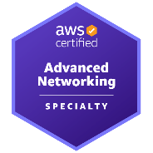
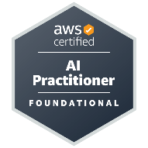
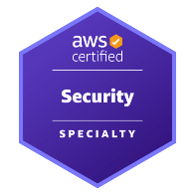
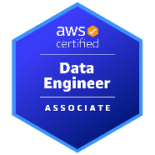
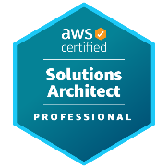
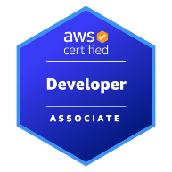
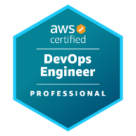
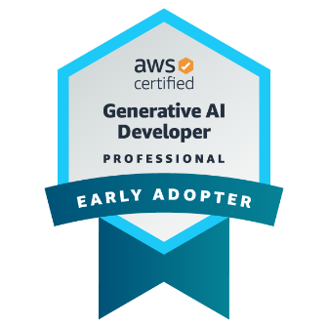


Dear Hiring Team,

Imma be honest...

I never know exactly what an organization is looking for when it publishes a job requisition like this one, but I do believe I may be the kind of applicant who brings more than a checklist of technical skills to the table.

I am a hands-on software engineering leader with more than 20 years of experience building, modernizing, and scaling enterprise applications across banking, finance, healthcare, manufacturing, energy, and professional services. The opportunity to build a next-generation digital platform is especially appealing to me because it combines the work I enjoy most: writing high-quality code, shaping architecture, improving engineering practices, mentoring developers, and delivering secure, resilient software in an agile product environment.

My background includes deep experience with Java, Spring Boot, REST APIs, databases, distributed systems, Git-based development, automated testing, CI/CD, Kubernetes, AWS cloud architecture, and enterprise software delivery. I understand the discipline required in agentic technology, where reliability, performance, security, maintainability, and risk awareness must be built into every stage of the SDLC.

I also bring modern AI and cloud transformation expertise, having led adoption initiatives involving GitHub Copilot, Microsoft Copilot Studio, Cursor AI, Amazon Bedrock, Agentic AI, and secure enterprise AI application development. In addition, I hold every active AWS certification, including certifications focused on Agentic AI, machine learning, architecture, security, and DevOps.

I would be excited to bring my combination of hands-on Java and Spring Boot engineering, technical leadership, cloud expertise, and practical delivery focus to you. I welcome the opportunity to discuss how I could contribute to the successful development of your digital platform.

Sincerely,
Cameron McKenzie
Cameron McKenzie
Responsible Leadership in the Age of Generative and Agentic AI

While I’ve worn many hats over the past 20 years, I always think of myself as a developer at heart. I love technology, I love solving tough problems, and I love that rush that comes when a vision comes to fruition.
I’m also a communicator, team builder, teacher and GitHub Copilot advocate who has spent the past few years building life-changing, Generative and Agentic AI solutions in the AWS cloud. A “Golden Jacket” holder with all 12 AWS certifications, I’m here to help with all of your software architecture, DevSecOps, Agentic AI and application delivery needs.
UDEMY COURSES
I currently have over 35 AWS, GCP, Azure and Java courses on Udemy.

Full-Stack GitHub Copilot in JS & Python
GCP Generative AI Leader Masterclass
AWS Solutions Architect Professional Prep
Spring AI Masterclass for IntelliJ Developers
Official ISACA CISA Exam Prep Course
Azure Developer Certification Prep
Docker & Kubernetes KCNA Exam Prep
ISC2 System Security Practice Exam (SSCP)
Azure Data Scientist Practice Tests
AWS DevOps Professional Exam Course
Pass the Jira Cloud Projects Certification
Official ISACA CISM Exam Prep Course
AWS Machine Learning (Sagemaker) Prep
GitHub Copilot Masterclass for Java & Spring

EDUCATION
Bachelor of Science - Chemistry
Western University
Information Systems Diploma
Durham College
SOCIALS
YouTube - >35,000 Subscribers
youtube.com/@cameronmcnz
LinkedIn
www.linkedin.com/in/cameronwmckenzie
Phone
(407) 214-1352
Email
agentic@mcnz.com
Address
Charlotte NC

